Local Financial Advisor First-Ever Singaporean to Join Global Organization’s 2022 Leadership Team

Singapore (Sept. 1, 2021) — The Million Dollar Round Table (MDRT) appoints Carol Kheng, ChFC, Secretary of its 2022 Executive Committee. The first Singaporean member of the global leadership team, Kheng will take office Sept. 1, 2021, joining four other financial services leaders in supporting financial professionals as they reach new levels of success at each stage of their career.

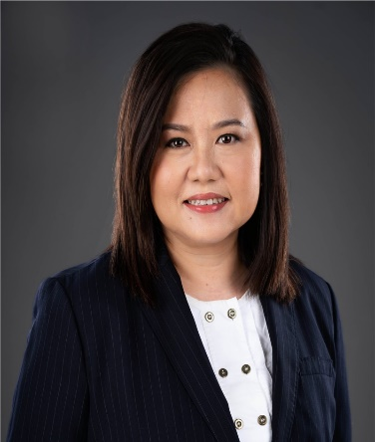
Kheng is a private wealth consultant with Prudential Assurance Company Singapore, where she was the founding member and chairperson of Prudential’s MDRT club. A 23-year MDRT member, Kheng’s proficiency in wealth consulting has merited her one Court of the Table (COT) qualification, a coveted honor for top performers in the MDRT organization, while her extensive MDRT volunteerism includes roles as Divisional Vice President of the Global Conference Program General Arrangements Division, Divisional Vice President of the Practice Management Division and Chair of the Annual Meeting ConneXion Zone Committee. Kheng is also a Gold Knight of the MDRT Foundation and served on its Board of Trustees.

As Secretary, Kheng will focus on driving holistic support for the financial services profession worldwide, to help professionals reach new levels of peak performance at every level. Together with the Executive Committee, Kheng will focus on providing continued resources to the growing Southeast Asian membership base and pushing for increased connectivity and engagement across MDRT’s global membership.
Carol Kheng, ChFC, is the first Singaporean member to join MDRT’s Executive Committee and is poised to propel members to increasing levels of success throughout their entire career journey, through MDRT’s Family of Brands.

“Since spearheading Prudential’s MDRT club in 2005, I’ve seen first-hand the value-add MDRT provides individual advisors and the profession as a whole, and I consider it an absolute honor to be nominated as the first-ever Singaporean Executive Committee member,” Kheng said. “As we continue navigating the impact of the pandemic, both in Singapore and worldwide, it’s my goal to ensure all members have the resources they need to continue feeling supported and uplifted – so they can lead their practice and clients to prosperity – no matter where they are in their career.”

MDRT’s 2022 initiatives will focus on equipping and empowering members to reach new career highs via the MDRT Family of Brands. From MDRT to the MDRT Academy and MDRT Global Services, members will have access to a shared learning culture and proven strategies for success at every stage of their career, empowering them to live more rewarding personal and professional lives and accelerate their success.

Kheng joins President Randy Scritchfield, CFP, LUTCF, a 37-year member; First Vice President Peggy Tsai, RFP, CCFP, a 20-year member; Second Vice President Gregory Gagne, ChFC, a 22-year member; and Immediate Past President Ian Green, Dip PFS, a 23-year member. The 2022 Executive Committee is committed to elevating new advisors, keeping experienced advisors reaching for more and accelerating leadership growth.

About MDRT
Million Dollar Round Table (MDRT), The Premier Association of Financial Professionals®, is a global, independent association of the world's leading life insurance and financial services professionals from more than 500 companies in 70 nations and territories. MDRT members demonstrate exceptional professional knowledge, strict ethical conduct and outstanding client service. MDRT membership is recognized internationally as the standard of excellence in the life insurance and financial services business. For more information, please visit https://www.mdrt.org/ and follow them on Twitter @MDRtweet.

Contact Information

Giang Ngo Sara Pardys
MDRT G&S Business Communications
847-993-4955 312-872-3956
gngo@mdrt.org spardys@gscommunications.com
@MDRTweet @gs_comms

# # #

