2022 MDRT Executive Committee Drives Comprehensive Support for Financial Services, Empowering New Levels Success

PARK RIDGE, Ill. (Sept. 1, 2021) — The 2022 MDRT Executive Committee ushers in an integrated approach to supporting the financial services profession, as Randy Scritchfield, CFP, LUTCF takes his place as 96th President and Carol Kheng, ChFC, joins as Secretary. The Executive Committee will empower financial services professionals to redefine the limits of success, equipping them to rise, excel and lead throughout the full cycle of their careers.
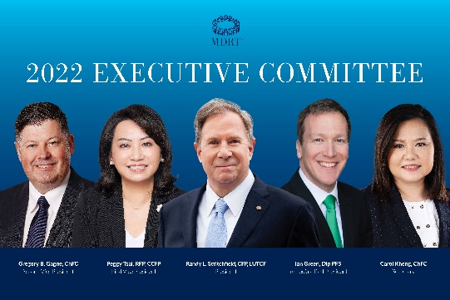
2022 MDRT Executive Committee
From left to right: Gregory Gagne, Peggy Tsai, Randy Scritchfield, Ian Green, Carol Kheng.
Scritchfield, a 37-year member, succeeds 23-year member Ian Green, who will become the Immediate Past President. Peggy Tsai, RFP, CCFP, a 20-year member, and Gregory Gagne, ChFC, a 22-year member, will move into their new roles as First and Second Vice Presidents while Carol Kheng, ChFC, a 23-year member, will serve as Secretary.

The 2022 Executive Committee remains committed to providing support and delivering value for members as the impact of the pandemic continues. The MDRT Productivity Action Plan will be extended in 2022, establishing updated membership requirements enabling members to focus on leading clients to continued success. In addition, MDRT will provide added value to the global membership with the launch of the MDRT Productivity Action Plan Special Content, delivering MDRT’s high-caliber content exclusively to members via multiple platforms and formats.

In North America, the Executive Committee will also support the newly formed North America Channel Relations Team, charged with expanding MDRT’s footprint in North America. This effort focuses on connecting companies and individuals with MDRT’s wide-ranging support of the profession through the Family of Brands – three MDRT-driven associations, tailored to help members reach new heights at all stages of their career. In addition to the inspiration, learning and achievement that are the hallmark of MDRT, the MDRT Academy aids advisors seeking the boost they need to reach MDRT-levels of production. MDRT’s newest association, MDRT Global Services, aims to enhance not only its members’ careers, but the entire profession, through immersive leadership development for home and field office leaders.

“As we look forward to the next year, MDRT is committed to ensuring our members remain well-supported – to not only help them navigate the ongoing impact of the pandemic, but help their clients and practice come out on top,” Scritchfield said. “With the Family of Brands offering unique value, tailored to each phase of an advisor’s career, we’re excited to see members put these resources into practice, to reach new levels of peak performance, enhance their career and deliver the highest quality service to their clients.”

Together, the Executive Committee is poised to broaden MDRT’s impact on the financial services profession. Scritchfield brings extensive MDRT experience to the leadership team with three Court of the Table and 20 Top of the Table qualifications. An MDRT Foundation Excalibur Knight, Scritchfield is also a member of its Inner Circle Society and has served on its Board of Trustees. His extensive MDRT volunteer history includes serving on MDRT’s Management Council six times and as a Committee Chair nine times. Among his leadership roles, Scritchfield has served as Chair of the Top of the Table Advisory Board and Divisional Vice President of Annual Meeting Program Development.

Newcomer Kheng of Singapore also has a long history of involvement with MDRT and MDRT Foundation volunteerism, including roles as Divisional Vice President of the Global Conference Program General Arrangements (PGA) Division, Chair of the Annual Meeting ConneXion Zone Committee and Divisional Vice President of the 2014 MDRT Experience meeting.

About MDRT
Million Dollar Round Table (MDRT), The Premier Association of Financial Professionals®, is a global, independent association of the world's leading life insurance and financial services professionals from more than 500 companies in 70 nations and territories. MDRT members demonstrate exceptional professional knowledge, strict ethical conduct and outstanding client service. MDRT membership is recognized internationally as the standard of excellence in the life insurance and financial services business. For more information, please visit https://www.mdrt.org/ and follow them on Twitter @MDRtweet.

Contact Information

Giang Ngo
MDRT
847-993-4955
gngo@mdrt.org
@MDRTweet
Sara Pardys
G&S Business Communications
312-872-3956
spardys@gscommunications.com
@gs_comms

# # #

