Maryland Advisor Appointed President of the Global Association MDRT, Will Lead Rollout of Transformational Financial Services Industry Initiatives

DAMASCUS, Md. (Sept. 1, 2021) — MDRT appoints Randy Scritchfield, CFP, LUTCF, as the 96th President of the association’s Executive Committee. Scritchfield, founder and president of retirement planning firm Montgomery Financial Group, will oversee the global rollout of the MDRT Family of Brands, a game-changing initiative of three MDRT-driven associations, designed to propel more than 90,000 global MDRT members to new levels of success at all stages of their careers.

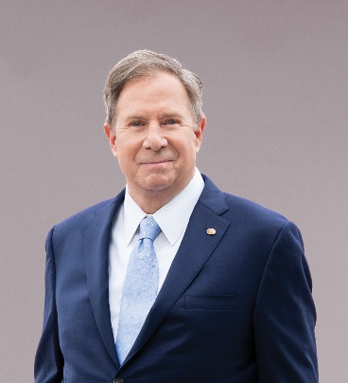
Scritchfield will succeed 23-year member Ian Green, Dip PFS, who transitions to Immediate Past President on Sept. 1. Bringing a group mentality to his new role, Scritchfield acknowledges the impact of Green and others who came before him, along with those who will succeed him. He views his role as a motivator, trusting the soundness of previously established initiatives – including the Productivity Action Plan, which MDRT is extending into 2022 – and focusing his leadership on building momentum around newer initiatives like the MDRT Family of Brands.
96th President of MDRT Randy Scritchfield, CFP, LUTCF, will oversee the expanded rollout of the MDRT Family of Brands and ensure MDRT members have the support they need to recover from the COVID-19 pandemic.

Under Scritchfield, MDRT will continue to tailor its support globally, providing members with the resources they need based on the challenges and opportunities of their geography. As always, MDRT will produce best-in-class educational content and proven insights from its global membership via the MDRT Resource Zone, MDRT Study Groups and the MDRT App. MDRT will also continue to host member gatherings virtually or in-person as conditions allow. Working together, the entire MDRT Family of Brands will provide more targeted, more relevant support to advisors at all stages of their professional and personal journeys.

“As we continue grappling with the impacts of the pandemic, we’re committed to helping our profession not only recover, but prepare for the challenges we’ll face 10 and 20 years, from now,” Scritchfield said. “We look forward to reaffirming our dedication to our global profession, as we support and learn from the members of our expanding MDRT family.”

Scritchfield is a 37-year MDRT member with three Court of the Table and 20 Top of the Table qualifications. He is also an MDRT Foundation Excalibur Knight, a member of its Inner Circle Society and a previous member of its Board of Trustees. Before starting his financial services career, Scritchfield ran a restaurant, where he learned valuable self-discipline and analytical skills that he has carried into his retirement planning practice and MDRT leadership.

About MDRT
Million Dollar Round Table (MDRT), The Premier Association of Financial Professionals®, is a global, independent association of more than 90,000 of the world's leading life insurance and financial services professionals from more than 500 companies in 70 nations and territories. MDRT members demonstrate exceptional professional knowledge, strict ethical conduct and outstanding client service. MDRT membership is recognized internationally as the standard of excellence in the life insurance and financial services business. For more information, please visit www.mdrt.org and follow them on Twitter @MDRtweet.

Contact Information

Giang Ngo
MDRT
847-993-4955
gngo@mdrt.org
@MDRTweet
Sara Pardys
G&S Business Communications
312-872-3956
spardys@gscommunications.com
@gs_comms

# # #

